Additional Notes

Drone Program:

Quote:
"As The Intercept reported, Zaidan frequently travels to regions with known terrorist activity in order to interview insurgents and report the news. But rather than questioning the machine learning that produced such a bizarre result,"
Actually having found a dude that is regularily traveling in these areas and interviews terrorists is not a "bizarre" result. Its pretty good.
No, incorrectly classifying a journalist as an "Al Qaeda terrorist" for assassination is not "pretty good", it's terrible - it shows that the classifier has no concept of the role of journalist. And if has false positives for something as obvious as a journalist, then it's highly likely that it has false positives for other innocent professions, particularly civilians who travel (e.g. truckers, taxi drivers, couriers etc.) They are literally just training it on the data patterns of "known couriers", so that's exactly what they're going to match - everyone who has a job that looks a bit like a courier.
The default categorisation for someone killed by drone strike is "enemy killed in action". This means that their data patterns in turn are used to classify other people who behave like them for extermination, without any positive finding that they were actually terrorists! One military source described the process as "insane"”

Quote:
The documents show that the military designated people it killed in targeted strikes as EKIA — “enemy killed in action” — even if they were not the intended targets of the strike. Unless evidence posthumously emerged to prove the males killed were not terrorists or “unlawful enemy combatants,” EKIA remained their designation, according to the source. That process, he said, “is insane. But we’ve made ourselves comfortable with that. The intelligence community, JSOC, the CIA, and everybody that helps support and prop up these programs, they’re comfortable with that idea.”
The source described official U.S. government statements minimizing the number of civilian casualties inflicted by drone strikes as “exaggerating at best, if not outright lies.”
The whole drone system is biased towards classifying people as terrorists if they are killed by a drone strike. Was there a 12 year old boy in the house? Well, that's a "military aged male", so he's an EKIA by default, so that's another successful strike!

Quote:
Westmoreland was a technician who was part of the 73rd Expeditionary Air Control Squadron in Kandahar, Afghanistan, and the 606th Air Control Squadron in Germany. He received a performance report at the end of his tour of duty, which indicated he had assisted in 200-plus “enemy kills” and 2,400 close air missions. He knew this was not accurate.

Quote:
“Enemies aren’t always enemies. Military-age male is 12 years-old,” Westmoreland stated. “If I’m being held responsible in my performance report—and I’ve thought about this a long time, if all the signals are coming through us, then that implicates anybody else who these signals are going through, including Germany, and I believe it’s immoral and just unethical to do that with a foreign country and not their citizens because we’ve broken their trust and that puts us [in] a bad position.”
Westmoreland relayed signals between the operations center, where he worked, and the Ramstein Air Base in Germany. He also explained, “If you have imagery intelligence and signals intelligence, it’s very possible that whoever your target is might have traded out their SIM card on the black market and this happens quite often. There pretty wise to it.
“There’s always the off-chance that you could end up targeting somebody, who is totally innocent,” Westmoreland added. “Of course, that’s usually not counted. That’s usually confirmed as an enemy killed.” And, if the basis for a strike involves human intelligence, the informant is oftentimes lying to get money.
Quote:
You are arguing that there isn't a closed loop system that gathers intelligence and automatically kills people. But that isn't the point - the point is that there is an official assassination programme that relies heavily on metadata and automatic classification of that metadata. Sure, there is still a human in the loop, but that human is highly dependent on the system. If the classifiers identify an individual as being "Al Qaeda" and flag that to a human operator, then it is likely that operator will in turn flag that person for assassination. "We kill people based on metadata."

Quote:
Classic logical fallacy, I wonder how the NSA and the US governement could not see this. Let's take an hypothetical example:
If I told you I designed a "detector" that can tell with 99.9% accuracy whether someone is a serial-killer or not.
You'd say: brilliant!!! 99.9% is almost perfect!!
Wrong.
Let's take the US population of 300.000.000 people, and assume we have one serial killer out of 1.000.000 people.
We run my detector on the entire population, so we can get rid of serial killers for good.
What do we find ?
300.300 people.
- 300.000 innocents (false positives, since 99.9% means 1 person out of 1000 will be a false positive)
- 300 guilty (assuming we don't have false negatives here, since we can also have 1 out of 1000)
And that's assuming that my machine is 99.9% of the time correct... which seems to be far from the case here.

Quote:
The example criteria for matching a terrorist are how poor people in the Third World use mobile phones. They turn off the phones frequently to save batteries, as they have to go to a tea shop to recharge, as they don't have electicity. They don't often call - in fact they use deliberate missed calls, expecting the richer person to call back. Mostly they get only incoming calls. Some use multiple SIMs from different providers, to allow for variable coverage.
So what they are picking up from those indicators are poor people. That helps reduce the compensation costs of false positives.

Machine Learning:

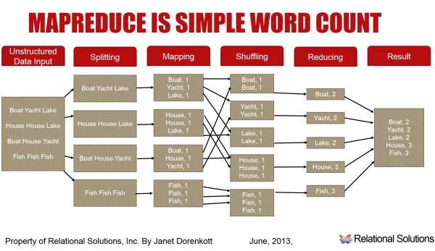
In machine learning and statistics, classification is the problem of identifying to which of a set of categories (sub-populations) a new observation belongs, on the basis of a training set of data containing observations (or instances) whose category membership is known. An example would be assigning a given email into "spam" or "non-spam" classes or assigning a diagnosis to a given patient as described by observed characteristics of the patient (gender, blood pressure, presence or absence of certain symptoms, etc.). Classification is an example of pattern recognition.
In the terminology of machine learning,[1] classification is considered an instance of supervised learning, i.e. learning where a training set of correctly identified observations is available. The corresponding unsupervised procedure is known as clustering, and involves grouping data into categories based on some measure of inherent similarity or distance.
Often, the individual observations are analyzed into a set of quantifiable properties, known variously as explanatory variables or features. These properties may variously be categorical (e.g. "A", "B", "AB" or "O", for blood type), ordinal (e.g. "large", "medium" or "small"), integer-valued (e.g. the number of occurrences of a particular word in an email) or real-valued (e.g. a measurement of blood pressure). Other classifiers work by comparing observations to previous observations by means of a similarity or distance function.
An algorithm that implements classification, especially in a concrete implementation, is known as a classifier. The term "classifier" sometimes also refers to the mathematical function, implemented by a classification algorithm, that maps input data to a category.
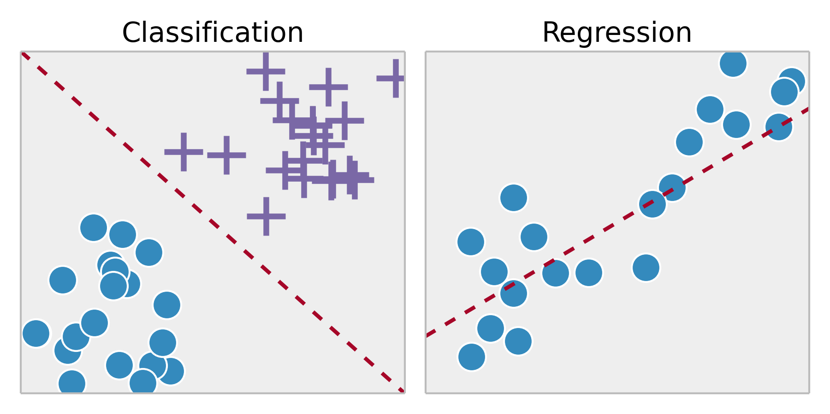
Regression involves estimating or predicting a response. Classification is identifying group membership.
Regression and classification are both related to prediction, where regression predicts a value from a continuous set, whereas classification predicts the 'belonging' to the class.
eg : price of a house depending on the 'size' (sq. feet or whatever unit) and say 'location' of the house, can be some 'numerical value' (which can be continuous) : this relates to regression.
Similarly the prediction of price can be in words, viz., 'very costly', 'costly', 'affordable', 'cheap', and 'very cheap' : this relates to classification.
Neural networks can be used only with numerical variables
Variables in a decision tree are usually represented by circles.

Explanation of decision tree
A decision tree is a set of rules used to classify data into categories. It looks at the variables in a data set, determines which are most important, and then comes up with a, well, tree of decisions which best partitions the data. The tree is created by splitting data up by variables and then counting to see how many are in each bucket after each split.
The key idea is that the procedure to create decision trees is recursive. For a set (S) of observations, the following algorithm is applied:
- If every observation in S is the same class or if S is very small, the tree becomes an endpoint, labeled with the most frequent class.
- If S is too large and it contains more than one class, find the best* rule based on one feature (e.g., "is weight > 150?") to split it into subsets, one for each class.
If you had to go to step 2, apply step 1 to each new subset. If your subsets need to go to step 2, apply step 1 to the sub-subsets, etc. When everything is split up appropriately (into buckets that are very small or entirely one class), you have a set of rules that look like a tree.**

Here's a minimum example. Given only the gender and weight of a person, can we predict whether they are Japanese or American?
If this is the training set:
Name/Weight (lbs.)/Sex/Nationality
Larry 195 M American
Jerry 190 M American
Carrie 160 F American
Cheri 165 F American
Yoshi 165 M Japanese
Yasuo 160 M Japanese
Michiko 130 F Japanese
Noriko 140 F Japanese
... then a decision tree would look like this:
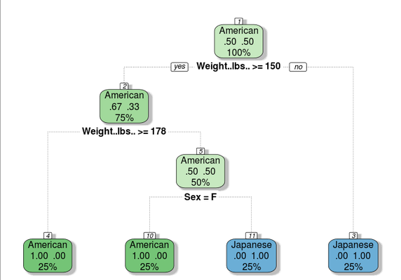
First, the model checks if a person is under 150 pounds. If so, they're classified as Japanese. If not, it sees if their weight is over 177 pounds. If so, they're American. If not, the last question asks whether it's a man or woman. With these three questions, you can use a person's sex and weight to predict what their nationality is. E.g., if you know a man is 200 pounds, the model predicts that he's American.
This example is convenient because the tree can perfectly explain the data--in the real world, there is overlap; there are fat Japanese people and skinny Americans. The model would be optimized to make the largest possible number of correct predictions, even though it can't be perfect.
(Note: decision trees are used for predicting continuous variables also, as opposed to categorical variables. It's easier to explain if I stick to categories.)
* The "best" branching rule is the one that results in the most information gain in most tree-generating algorithms.
** Trees are usually "pruned" to avoid overfitting. The pruning algorithm removes final nodes, based on misclassification rates, so that the model is a little more general.

